**Program 11: "XYZ Ltd" is a US based IT company with 1000 employees, out of which 10 employees are based on India and working in different departments. Out of 10 employees, few are managers who are leading a team also. Write a program to create a class "Employee" that has data members as follows:**

|  |  |
| --- | --- |
| **Empid** | **Employee ID** |
| **Empname** | **Employee Name** |
| **dept** | **Department Name ( Coding / Testing/ Developer** |
| **Desg** | **Designation (Fresher /HR/ Team / Leader / Manger)** |
| **Input()** | **Take input all employee records** |
| **Display()** | **Display those Employee Id and Name who is in Developer team and designation are manager.** |

**Code:**

|  |
| --- |
| // Employee11.cs file  using System;  using System.Collections.Generic;  using System.Linq;  using System.Threading.Tasks;  namespace Second_Practical  {  public class Employee11  {  private int id = 0;  private string name = "";  private string department = "";  private string designation = "";  public void Input(){  Console.WriteLine("Enter the id of the employee: ");  id = Convert.ToInt32(Console.ReadLine());  Console.WriteLine("Enter the name of the employee: ");  name = Console.ReadLine();  Console.WriteLine("Enter the department of the employee: ");  department = Console.ReadLine();  Console.WriteLine("Enter the designation of the employee: ");  designation = Console.ReadLine();  }  public void Display(){  Console.WriteLine("The id of the employee is: " + id);  Console.WriteLine("The name of the employee is: " + name);  Console.WriteLine("The department of the employee is: " + department);  Console.WriteLine("The designation of the employee is: " + designation);  }    }  }  //Program.cs file  using System;  using Second_Practical;  public class Program  {  public static void Main(string[] args)  {  Employee11 emp = new Employee11();  emp.Input();  emp.Display();  Employee11 emp2 = new Employee11();  emp2.Input();  emp2.Display();    }  } |

**Output:**

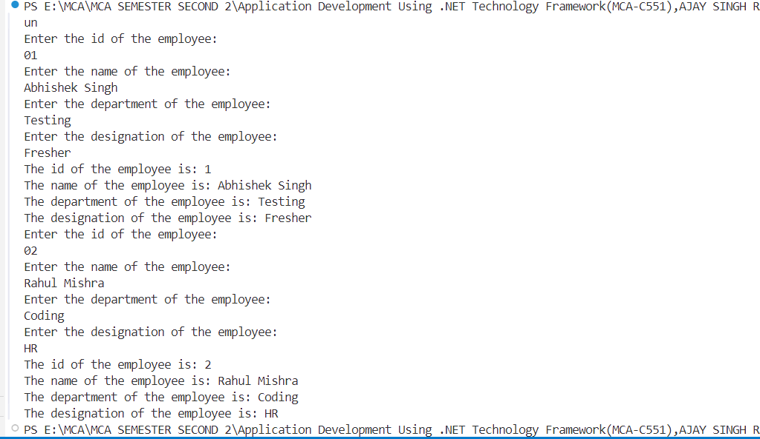

**Program 12: A shopkeeper in Delhi started facing a lot of problems when more clients began coming in. Until now, the shopkeeper used to manually issue bills, but now he needed software. Create a program in such a way that the shopkeeper can give the client a bill, which includes the name of all products, quantity, price, discount (if applicable), and the total bill generated.**

**Code:**

|  |
| --- |
| // Progeram.cs file  using System;  using System.Collections.Generic;  class Program  {  class Product  {  public string Name { get; set; }  public int Quantity { get; set; }  public double Price { get; set; }  public double Discount { get; set; } // Discount in percentage    public double GetTotal()  {  double total = Quantity * Price;  double discountAmount = total * (Discount / 100);  return total - discountAmount;  }  }  static void Main()  {  List<Product> products = new List<Product>();  Console.WriteLine("Welcome to the Billing System\n");    while (true)  {  Product p = new Product();  Console.Write("Enter product name (or type 'done' to finish): ");  p.Name = Console.ReadLine();  if (p.Name.ToLower() == "done") break;  Console.Write("Enter quantity: ");  p.Quantity = Convert.ToInt32(Console.ReadLine());    Console.Write("Enter price per unit: ");  p.Price = Convert.ToDouble(Console.ReadLine());    Console.Write("Enter discount (%): ");  p.Discount = Convert.ToDouble(Console.ReadLine());    products.Add(p);  Console.WriteLine("Product added successfully!\n");  }  Console.WriteLine("\n------ Bill Summary ------");  double grandTotal = 0;    Console.WriteLine( "Product\t\t\tQuantity\tPrice\t\tDiscount\t\tTotal");  Console.WriteLine("------------------------------------------------------------");    foreach (var item in products)  {  double total = item.GetTotal();  grandTotal += total;  Console.WriteLine(item.Name+"\t\t\t"+item.Quantity+"\t\t"+ item.Price+"\t\t"+item.Discount + "%"+"\t\t"+total);  }  Console.WriteLine("------------------------------------------------------------");  Console.WriteLine("Grand Total: Rs. " + grandTotal);  Console.WriteLine("\nThank you for shopping!\n");  }  } |

**Output:**

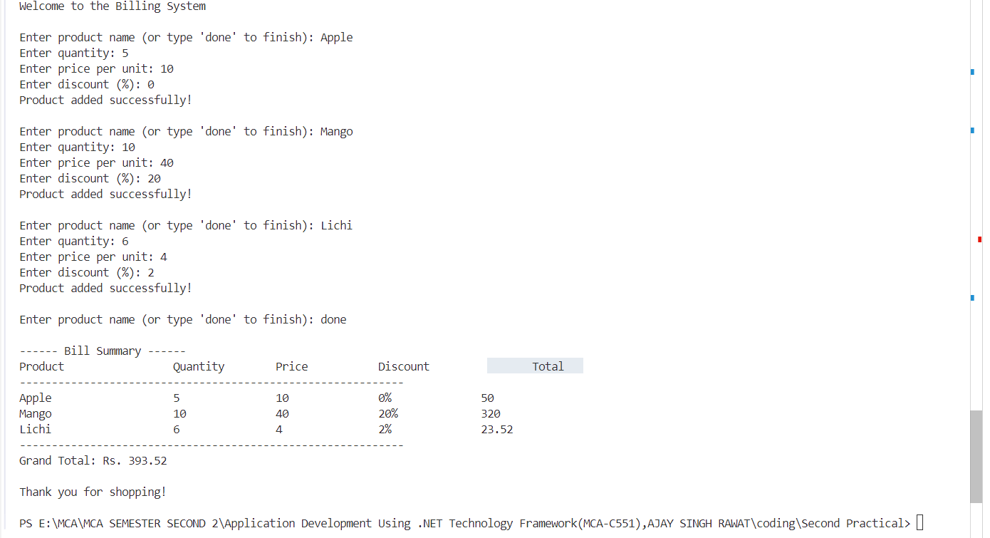

**Program 13: Write a program to take any string from user and count the total number of 'a' character (lower as well as upper) in a string.**

**Code:**

|  |
| --- |
| //StringCount.cs file  using System;  using System.Collections.Generic;  using System.Linq;  using System.Threading.Tasks;  namespace Second_Practical  {  public class StringCount13  {  public int CountCharA(string str){  int count = 0;  for(int i= 0 ; i<str.Length;i++){  if(str[i]=='A'||str[i]=='a'){  count++;  }    }  return count;  }  }  }  //Program.cd file  using System;  using Second_Practical;  public class Program  {  static void Main(string[] args)  {  StringCount13 s = new StringCount13();  Console.WriteLine("Enter the string: ");  string str = Console.ReadLine();  int a = s.CountCharA(str);  Console.WriteLine(a);  }  } |

**Output:**

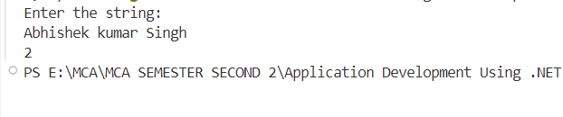

**Program 14: Write a program to take any string from user and count total number of words in a string without using any inbuilt function.**

**Code:**

|  |
| --- |
| //StringCount13.cs file  using System;  using System.Collections.Generic;  using System.Linq;  using System.Threading.Tasks;  namespace Second_Practical  {  public class StringCount13  {  public int CountCharA(string str){  int count = 0;  bool flags = false;  for(int i= 0 ; i<str.Length;i++){    if(str[i]!=' '){  if(flags==false){  count++;  flags = true;  }  }else{  flags = false;  }  }  return count;  }  }  }  // Program.cs file  using System;  using Second_Practical;  public class Program  {  static void Main(string[] args)  {  StringCount13 s = new StringCount13();  Console.WriteLine("Enter the string: ");  string str = Console.ReadLine();  int a = s.CountCharA(str);  Console.WriteLine(a);  }  } |

**Output:**

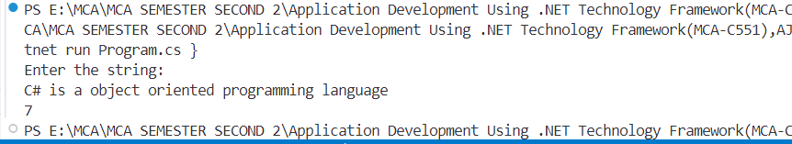

**Program 15: Write a program to take any string from user and check how many words are palindrome in a string without using inbuilt function.**

**Code:**

|  |
| --- |
| //StringCount13.cs file  using System;  using System.Collections.Generic;  using System.Linq;  using System.Threading.Tasks;  namespace Second_Practical  {  public class StringCount13  {  public int CountCharA(string str)  {  int count = 0;  string str1 = "";  for (int i = 0; i < str.Length; i++)  {  if (str[i] != ' ')  {  str1 = str1 + str[i];  }  else  {  string str2 = "";  for (int j = str1.Length - 1; j >= 0; j--)  {  str2 = str2 + str1[j];  }  if (str1 == str2)  {  count++;  }  str1 = "";  }  }  return count;  }  }  }  //Program.cs file  using System;  using Second_Practical;  public class Program  {  static void Main(string[] args)  {  StringCount13 s = new StringCount13();  Console.WriteLine("Enter the string: ");  string str = Console.ReadLine();  int a = s.CountCharA(str);  Console.WriteLine(a);  }  } |

**Output:**

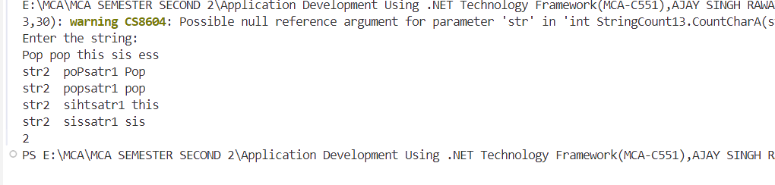

**Program 16: Write a program to take any string from user and convert each character into upper case. Don't use the inbuilt function.**

Example: str "Goal is goal" Result GOAL IS GOAL

**Code:**

|  |
| --- |
| // StringCount13.cs file  using System;  using System.Collections.Generic;  using System.Linq;  using System.Threading.Tasks;  namespace Second_Practical  {  public class StringCount13  {  char ToLower(char ch){  if(ch >= 'A' && ch <= 'Z'){  return (char)(ch + 32);  }  return ch;  }  public string CountCharA(string str)  {  string str1 = "";  for (int i = 0; i < str.Length; i++)  {  if (str[i] != ' ')  {  str1 = str1 + ToLower(str[i]);  }else{  str1=str1+" ";  }  }  return str1;  }  }  }  // Program.cs file  using System;  using Second_Practical;  public class Program  {  static void Main(string[] args)  {  StringCount13 s = new StringCount13();  Console.WriteLine("Enter the string: ");  string str = Console.ReadLine();  string a = s.CountCharA(str);  Console.WriteLine(a);  }  } |

**Output:**

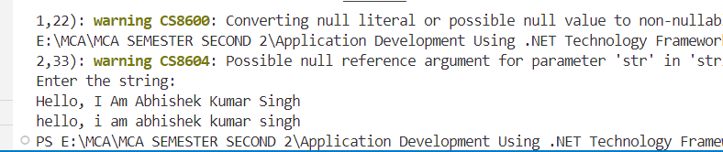

**Program 17: Write a program to take any string from user and count how many words in a string start with character 't'. Don't use the inbuilt function.**

**Code:**

|  |
| --- |
| // StringCount13.cs file  using System;  using System.Collections.Generic;  using System.Linq;  using System.Threading.Tasks;  namespace Second_Practical  {  public class StringCount13  {  public int CountCharA(string str)  {  int count = 0;  bool flags = false;  for (int i = 0; i < str.Length; i++)  {  if (str[i] != ' ')  {  if (flags == false)  {  if (str[i] == 't')  {  count++;  }  flags = true;  }  }  else  {  flags = false;  }  }  return count;  }  }  }  // Program.cs file  using System;  using Second_Practical;  public class Program  {  static void Main(string[] args)  {  StringCount13 s = new StringCount13();  Console.WriteLine("Enter the string: ");  string str = Console.ReadLine();  int a = s.CountCharA(str);  Console.WriteLine(a);  }  } |

**Output:**

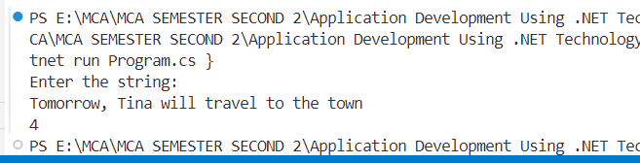

**Program 18: Take size of an array and array elements from the user. Write a program to count the occurrence of each element of an array and display.**

**Code:**

|  |
| --- |
| using System;  public class Program  {  static void Main(string[] args)  {  Console.WriteLine("Enter a size of array:");  int size = Convert.ToInt32(Console.ReadLine());  int[] arr = new int[size];  Dictionary<int, int> freq = new Dictionary<int, int>();  for (int i = 0; i < size; i++)  {  Console.Write("Enter " + (i + 1) + " Element: ");  arr[i] = Convert.ToInt32(Console.ReadLine());  if (freq.ContainsKey(arr[i]))  {  freq[arr[i]]++;  }  else  {  freq[arr[i]] = 1;  }  }  foreach (var pair in freq)  {  Console.WriteLine(pair.Key + ": " + pair.Value);  }  }  } |

**Output:**

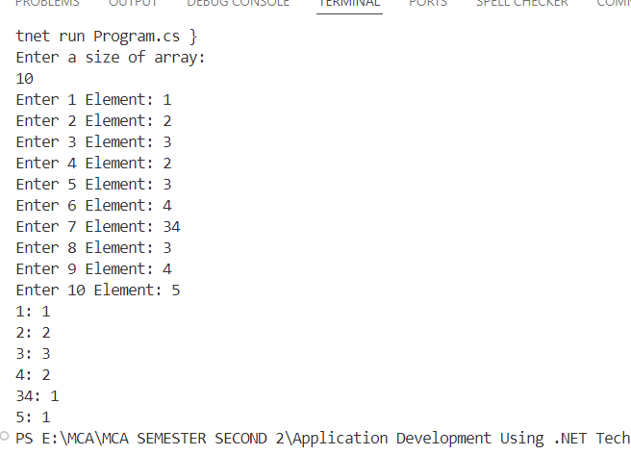

**Program 19: Write a program to take any string from user and count the total number of characters in each word. Don't use the inbuilt function.**

**Code:**

|  |
| --- |
| // StringCount.cs file  using System;  using System.Collections.Generic;  using System.Linq;  using System.Threading.Tasks;  namespace Second_Practical  {  public class StringCount13  {  public void CountCharA(string str)  {  int count = 0;  string str1 = "";  for (int i = 0; i < str.Length; i++)  {  if (str[i] != ' ')  {  count++;  str1 = str1+str[i];  }  else  {  Console.WriteLine(str1+": "+count);  count= 0;  str1 = "";@  }  }  }  }  }  // Program.cs file  using System;  using Second_Practical;  public class Program  {  static void Main(string[] args)  {  StringCount13 s = new StringCount13();  Console.WriteLine("Enter the string: ");  string str = Console.ReadLine();  s.CountCharA(str);  }  } |

**Output:**

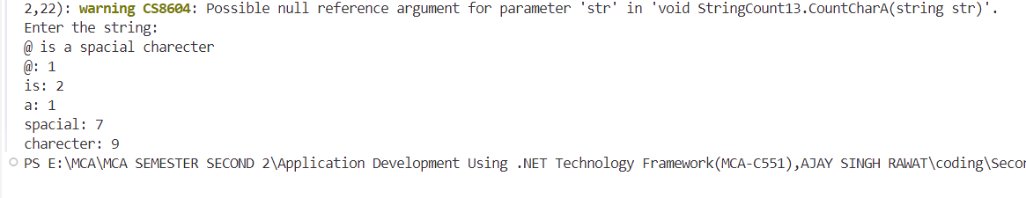

**Program 20: Create a structure named as "Faculty" that has date members as follows:**

* **Ecode: Faculty Employee Code**
* **Fname: Faculty Name**
* **Fexp: Faculty Experience**
* **Esalary: Faculty Salary**
* **Edept: Faculty Department Name**
* **Read (): Input all details of a faculty**

**Bonus (): Increment salary by 10%, if faculty teaching experience more than 2 years otherwise increment by 5%.**

**Show (): Display all details of a faculty after salary increment.**

**Code:**

|  |
| --- |
| using System;  struct Faculty  {  public int Ecode;  public string Fname;  public int Fexp;  public double Esalary;  public string Edept;  public void Read()  {  Console.Write("Enter Employee Code: ");  Ecode = Convert.ToInt32(Console.ReadLine());  Console.Write("Enter Name: ");  Fname = Console.ReadLine();  Console.Write("Enter Experience (in years): ");  Fexp = Convert.ToInt32(Console.ReadLine());  Console.Write("Enter Salary: ");  Esalary = Convert.ToDouble(Console.ReadLine());  Console.Write("Enter Department: ");  Edept = Console.ReadLine();  }  public void Bonus()  {  Esalary += Esalary * (Fexp > 2 ? 0.10 : 0.05);  }  public void Show()  {  Console.WriteLine("\n--- Faculty Details ---");  Console.WriteLine("Employee Code: " + Ecode);  Console.WriteLine("Name: " + Fname);  Console.WriteLine("Experience: " + Fexp + " years");  Console.WriteLine("Salary after Increment: Rs. " + Esalary);  Console.WriteLine("Department: " + Edept);  }  }  class Program  {  static void Main()  {  Faculty faculty = new Faculty();  faculty.Read();  faculty.Bonus();  faculty.Show();  }  } |

**Output:**

